Computer Language Diagrams

Normal Execution Order in a Diagram
The concept of normal execution order is already covered by the article Normal Execution Order. This article only explains its expression in a diagram.

If you do not indicate an order in which to execute the commands, then they may execute in an arbitrary order. Sometimes this is acceptable from a functional point of view. The diamonds representing the calls are simply placed inside the command definition as follows:

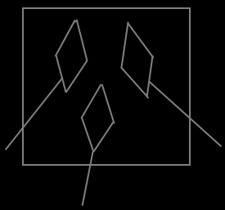

The order of execution of commands can also be determined by the input / output dependency of their parameters.

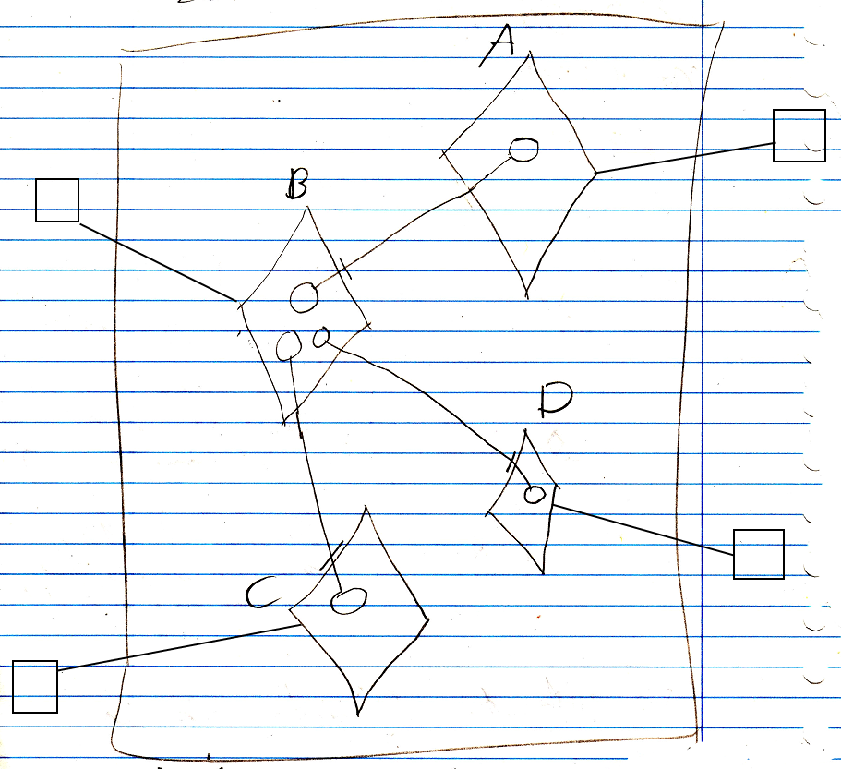

The access marks indicate the input / output direction.

The output of A goes into B. The two output objects of B respectively go into C and D. Therefore A executes first, then B, then C and D are executed in an arbitrary order.

This is an implicit notation, that overrides the notation for object reference direction. For more about parameter direction and its notation, see the articles Input, Output, Throughput and Input, Output, Throughput in a Diagram (both those article may not be written yet).

When the order of the commands should not be arbitrary or determined by input / output direction, then the order is explicitly drawn out in the diagram. This is what we are usually talking about when we refer to normal execution order. One command actually calls the next, but the call never returns to the caller. This is displayed as follows:

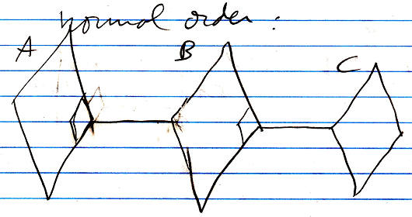

The first command to run is a command, that is nobody’s next statement, not even in the input, output dependency. In the diagram above, that would be A. The commands are executed in the order A, B, C. The fact, that B is followed up by A is displayed as a call from A to B. But the call never returns to A again. This is displayed as the call from A to B’s being stuck to the end of A, so that if you follow the line to B back to A, it does not enter back into A again: it does not return back into A.

The diagram notation also looks like a call to the end of a command.
The diamond stuck to the border of a call is actually called the Command End, and is an actual reference to the next command, but then called in a special way.

Normal execution order is also indicated for calls to execution control statements, like If calls and For calls.

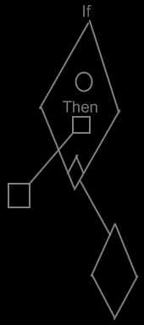

Normal execution order only puts command calls next to eachother, not command definitions. The normal-execution-order ‘call’ (stuck to the side of the command) is always the last call of a sub-command. It moves execution on to the next step.

See also: Normal Order, Input, Output, Throughput, Input, Output, Throughput in a Diagram

Author & Copyright: Jan-Joost van Zon Date: June 10, 2008 – June 10, 2008 Location: Oosterhout, The Netherlands Status: Finished

